System Analysis Project :

**Project Identification :**

Project Name **:**

**( Home Maintenance )**

* **Short Description about project:**

This application is designed to manage the booking process to fix a certain maintenance problem inside your home and it is a fun application that is easy to use for all people.

**System Request**

Project sponsor:

Team leader : Mohamed amer.

Business needs :

1. Waste of time.
2. Spending a lot of time finding services man.
3. Didn't known the cost should I pay.
4. Find less time to reply

Business requirements :

1. Provide online booking for mobile throw mobile app.
2. Provide notification for updates.
3. Providing the arrival time to your house.
4. Almost deciding the cost of your problem in your house.

Business value

1. 30% saving time.
2. 15% decrease in knowledge or awareness.
3. 50% determine the waiting time for repairing.
4. 5% Do not worry about money.

Special Issues or Constraints

1. Easy for all layers of society.
2. Very fast application.
3. Beautiful design.
4. High level of security.

**Feasibility Analysis**

Technical Feasibility

1. Providing annually update for this app.

The needed technologies :

* Web App.
* Mobile App.
* Cloud Computing Service It will host the web app, mobile App, Data Base and Notification Hub.
* Local Data Base.

**The Needed Employers:**

* Android developer.
* Back and end developer.
* Security engineer
* Designer.

Economic Feasibility:

1. The development costs of the system will be 150k $
2. Annual operating costs 50k $
3. Annual profit 20%

Organizational Feasibility:

1. Online documentation for public
2. This app for cities only
3. leader will have full access to the system
4. the others in the team will have limited access to the system

**Task Identification (At least six tasks must be identified)**

|  |  |
| --- | --- |
| System Request | Name of Task |
| 17-3-2019 | Start Date |
| 20-3-2019 | End Date |
| Mohamed kamal | Person assigned to task |
| High | Priority |
| Microsoft Word | Resources Needed |
| 72 Hours | Estimated Time |
| 4 Hours | Actual Time |

|  |  |
| --- | --- |
| Feasibility Study | Name of Task |
| 20-03-2019 | Start Date |
| 24-03-2019 | End Date |
| Mohamed amer | Person assigned to task |
| High | Priority |
| Internet | Resources Needed |
| 96 Hours | Estimated Time |
| 2.5 Hours | Actual Time |

|  |  |
| --- | --- |
| Pert Chart | Name of Task |
| 26-03-2019 | Start Date |
| 28-03-2019 | End Date |
| Mostafa shalaby | Person assigned to task |
| High | Priority |
| EDRAW | Resources Needed |
| 48 Hours | Estimated Time |
| 2.5 Hour | Actual Time |

|  |  |
| --- | --- |
| Gantt Chart | Name of Task |
| 26-03-2019 | Start Date |
| 28-03-2019 | End Date |
| Mostafa shalaby | Person assigned to task |
| Medium | Priority |
| EDRAW | Resources Needed |
| 48 Hours | Estimated Time |
| 2.25 Hour | Actual Time |

|  |  |
| --- | --- |
| Interview | Name of Task |
| 5-04-2019 | Start Date |
| 11-04-2019 | End Date |
| Mahmoud ramadan | Person assigned to task |
| High | Priority |
| Word & Internet | Resources Needed |
| 6 Days | Estimated Time |
| 2 Day | Actual Time |

|  |  |
| --- | --- |
| Questionnaire | Name of Task |
| 12-04-2019 | Start Date |
| 17-04-2019 | End Date |
| Mahmoud ramadan | Person assigned to task |
| High | Priority |
| Google Forms | Resources Needed |
| 5 Days | Estimated Time |
| 2 Days | Actual Time |

|  |  |
| --- | --- |
| DFD | Name of Task |
| 17-04-2019 | Start Date |
| 23-04-2019 | End Date |
| Mohamed kamal | Person assigned to task |
| High | Priority |
| EDRAW | Resources Needed |
| 6 Days | Estimated Time |
| 4 Days | Actual Time |

|  |  |
| --- | --- |
| Data Flow | Name of Task |
| 24-4-2019 | Start Date |
| 30-4-2019 | End Date |
| Mostafa kandeel | Person assigned to task |
| High | Priority |
| Word | Resources Needed |
| 6 Days | Estimated Time |
| 5 Days | Actual Time |

|  |  |
| --- | --- |
| Data Store | Name of Task |
| 24-4-2019 | Start Date |
| 30-4-2019 | End Date |
| Mostafa kandeel | Person assigned to task |
| High | Priority |
| Word | Resources Needed |
| 6 Days | Estimated Time |
| 3 Days | Actual Time |

|  |  |
| --- | --- |
| Process Specification | Name of Task |
| 1 - 5 -2019 | Start Date |
| 7 - 5 – 2019 | End Date |
| Mostafa abdo | Person assigned to task |
| High | Priority |
| Word | Resources Needed |
| 7 Days | Estimated Time |
| 4 Days | Actual Time |

|  |  |
| --- | --- |
| Normalization | Name of Task |
| 1. 5-2019 | Start Date |
| 6 - 5- 2019 | End Date |
| Mahmoud Ramadan | Person assigned to task |
| High | Priority |
| Word | Resources Needed |
| 5 Days | Estimated Time |
| 4 Days | Actual Time |

|  |  |
| --- | --- |
| ERD | Name of Task |
| 7-5-2019 | Start Date |
| 13-5-2019 | End Date |
| Mostafa abdo | Person assigned to task |
| Good | Priority |
| EDRAW | Resources Needed |
| 6 Days | Estimated Time |
| 5 Days | Actual Time |

|  |  |
| --- | --- |
| Database | Name of Task |
| 13-5-2019 | Start Date |
| 17-5-2019 | End Date |
| Mohamed kamal | Person assigned to task |
| High | Priority |
| Workbench | Resources Needed |
| 4 Days | Estimated Time |
| 2 Days | Actual Time |

**Pert Chart:**

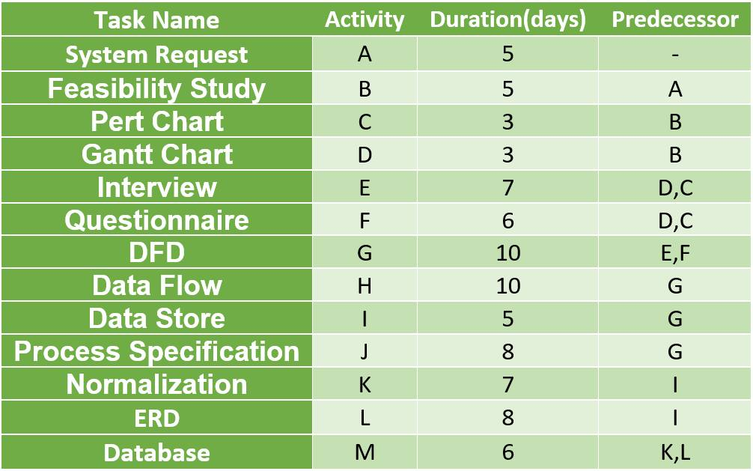

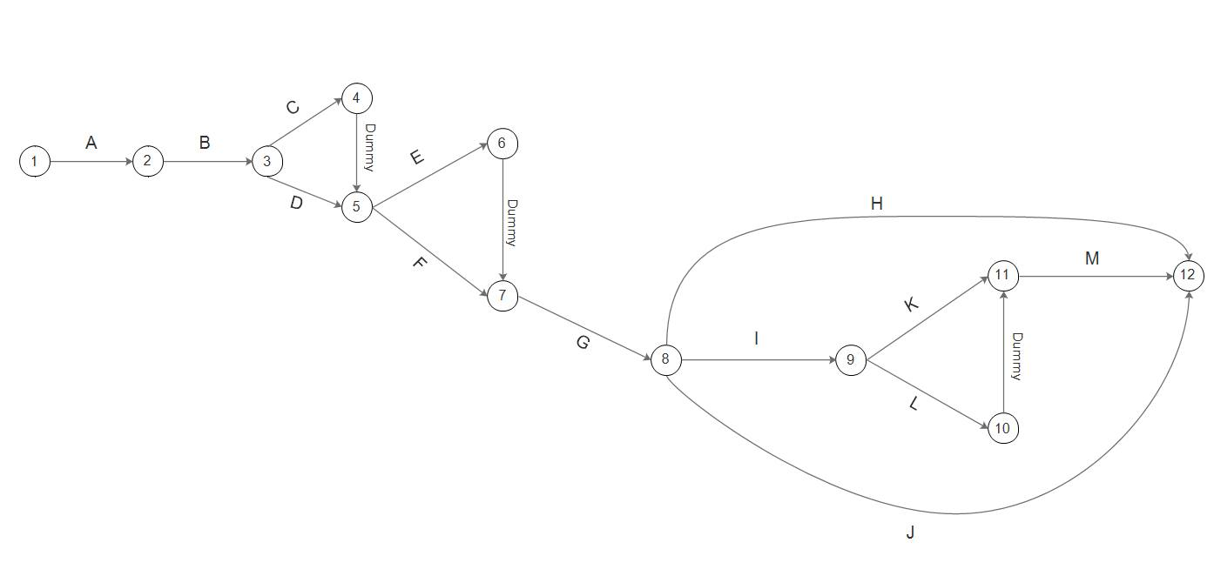

**Gantt chart:**

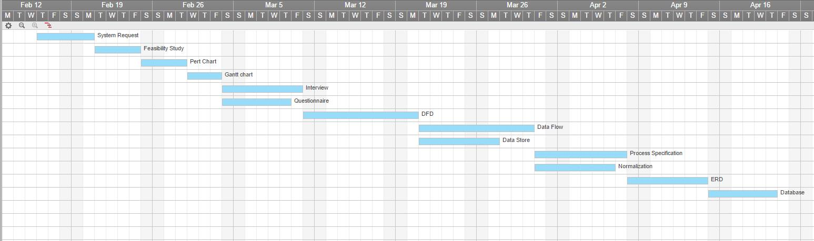

* **Interview**
* **What are the duties of a maintenance and repair worker?**

1-The maintenance and repair worker duties includes

2-Building partitions

3-Make a plaster or drywall repairs

4-Fix or paint roofs

5-Fix worn or broken parts

6-Maintain and repair specialized equipment’s

7-Inspect mechanical parts like motors, belts, drives, fluid8- levels and perform other maintenance

Actions

8-Drywall repairs

**=================================================**

* **What is the skill required to become maintenance and repair worker?**

1-To become maintenance and repair worker you must know

2-Basic calculation

3-Safety practices and handling tools

4-Basic plumbing repair skills

5-Basic knowledge of electrical wiring

6-Ability to decipher written or oral instructions

7-Physical agility

8-Able to lift and move heavy objects

**=========================================**

* **What is your opinion in your current system ?**

1☺ it is not good enough

2☺ most if things out of control

===========================================================================

* **How many customers you have monthly ?**

1-About 200 person

====================================

* **What is the main objectives of this company?**

**1☺**

Make a profit

2☺

Working to find means of relief for the citizens

3☺

Organization of working periods between different jobs

4☺

Keeping pace with global progress in housing

5☺

Prevent domain monopoly by local people

6☺

Providing job opportunities to contribute to the progress of society

=======================================

* **What is the most common problems in the company right now ?**

**1☺**

The inability to analyze data accurately

2☺

Financial management is not highly efficient

3☺

The desire to keep pace with change and progress

4☺

Get the latest capabilities to meet market requirements

5☺

Getting an appropriate number of workers does not strain the company in terms of salaries

6☺

Obtain suitable portable devices at prices to provide support for workers in the workplace

======================================

* **What do you think after using our software ?**

1-Save a large amount of time

2-Provide a large number of staff

3-Determine the number of working hours per employee

4-Savings in the consumption of equipment and machinery

5-The primary objective is fame

6-Reach customers as quickly as possible

Thank you for your time .

**~Interview report~**

After talking with the company manager, there are a number of important problems that need to be considered in order to build their program

The most important of these problems is the lack of good ability to analyze data because of the weakness of the current system in the good collection of information by dealing with customers

He also wanted to determine the number of working hours for each employee so as not to exceed the budget burden of the company and wanted to save as much as possible in the machines and equipment used by the company and determine the default period For these machines

And wants to send customers notifications of the latest updates of the company in the services and equipment in order to ensure the expansion of profits in the company and wants a copy of the telephone converter system Android and Web version in order to reach the company by the customers faster and at any time

* **Project DFD :**
* **LEVEL 0 :**

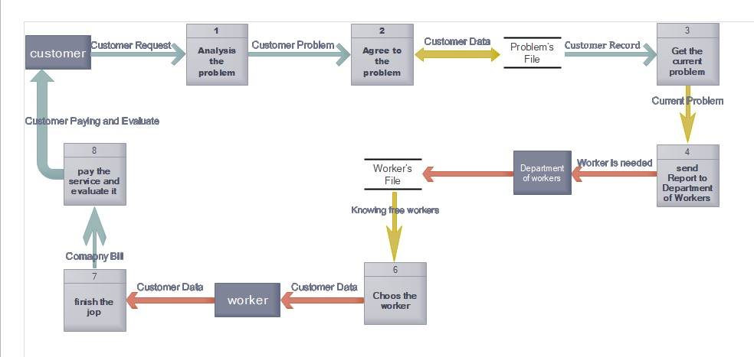

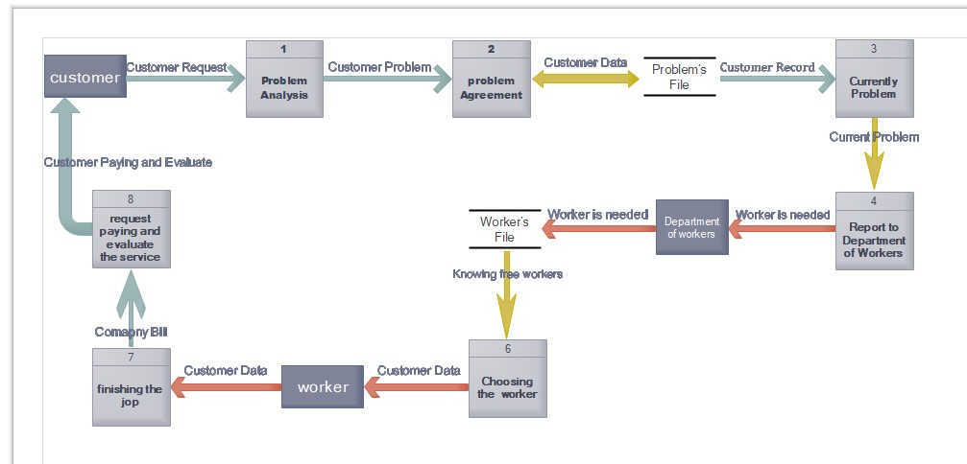

**DATA FLOW :**

|  |  |
| --- | --- |
| ID | 1 |
| Label | Customer Request |
| Description | Contain all thing about customer which you have need |
| Source | External (Customer) |
| Destination | Process1 (problem Analysis) |
| Type | form |
| Data Structure | Customer data |
| Volume/ Time | 5 day |
| Comments | This is information request for customer |

|  |  |
| --- | --- |
| ID | 2 |
| Label | Customer problem |
| Description | Describe the problem and send it to analysis to agree or disagree it |
| Source | (problem analysis) |
| Destination | Process2 (problem Agreement) |
| Type | Internal |
| Data Structure | Customer request |
| Volume/ Time | 3 day |
| Comments | Analyst analyze the problem and agree or disagree its |

|  |  |
| --- | --- |
| ID | 3 |
| Label | Customer data |
| Description | Describe the problem and sent it to problem 's file |
| Source | (problem Agreement) |
| Destination | Data store (problem 's file) |
| Type | file |
| Data Structure | Customer data |
| Volume/ Time | 3 day |
| Comments | Analyst analyze the problem and agree or disagree its |

|  |  |
| --- | --- |
| ID | 4 |
| Label | Customer Record |
| Description | Describe the problem and sent it to problem 's file |
| Source | (problem Agreement) |
| Destination | Process3(currently problem) |
| Type | Report |
| Data Structure | Problem's file |
| Volume/ Time | 4 day |
| Comments | Analyst sent agree or disagree to customer |

|  |  |
| --- | --- |
| ID | 5 |
| Label | Current problem |
| Description | Contain all thing about problem and describe it to Department |
| Source | Current Problem |
| Destination | Process4 (Report to Department of workers) |
| Type | Internal |
| Data Structure | Customer data |
| Volume/ Time | 2 day |
| Comments | This is information for current problem and describe it |

|  |  |
| --- | --- |
| ID | 6 |
| Label | Worker is needed |
| Description | Worker receive data from department to worked about it |
| Source | (Report to department of workers) |
| Destination | External(Department of workers) |
| Type | Screen |
| Data Structure | Customer data |
| Volume/ Time | 4 day |
| Comments | Worker ask about information about customer problem |

|  |  |
| --- | --- |
| ID | 7 |
| Label | Worker is needed |
| Description | Department send files to the correct worker |
| Source | External(Department of workers ) |
| Destination | Worker’s file |
| Type | Form |
| Data Structure | Customer data |
| Volume/ Time | 2 day |
| Comments | Department collect information about problem and send a worker |

|  |  |
| --- | --- |
| ID | 8 |
| Label | Knowing free workers |
| Description | Department send data to worker to chose the free |
| Source | (Department) External |
| Destination | Process6 (choosing the worker) |
| Type | Report |
| Data Structure | Customer data |
| Volume/ Time | 2 day |
| Comments | Department know the workers the problem and chose the correct worker |

|  |  |
| --- | --- |
| ID | 9 |
| Label | Customer data to and from customer |
| Description | Department send data to the worker after chose him |
| Source | Process6 (choosing the worker) |
| Destination | External (worker) |
| Type | Screen |
| Data Structure | Customer data |
| Volume/ Time | 2 day |
| Comments | Worker take data about problem and begin to work it |

|  |  |
| --- | --- |
| ID | 10 |
| Label | Customer data to and from customer |
| Description | Department send data to the worker after chose him |
| Source | External (worker) |
| Destination | Process7 (finishing the job) |
| Type | form |
| Data Structure | Customer data |
| Volume/ Time | 2 day |
| Comments | Worker take data about problem and finished work |

|  |  |
| --- | --- |
| ID | 11 |
| Label | Customer bill |
| Description | Worker finish the job and send bill to the service in the company |
| Source | (finishing the job) |
| Destination | Process8 (request paying and evaluate the service) |
| Type | Internal |
| Data Structure | Customer data |
| Volume/ Time | 1 day |
| Comments | After worker finish the job he sent bill to service to take money |

|  |  |
| --- | --- |
| ID | 12 |
| Label | Customer paying and evaluate |
| Description | Customer send the bill's money to the company |
| Source | (request paying and evaluate the service) |
| Destination | External (Customer) |
| Type | Screen |
| Data Structure | Customer data |
| Volume/ Time | 1 day |
| Comments | Company thanks the worker about he does in work |

**Data store :**

|  |  |
| --- | --- |
| **ID** | **D1** |
| **Alias** | **problem's file** |
| **Description** | **Contain all information about each problem that customer send it.** |
| **File type** | **computer_based** |
| **File format** | **Database** |
| **Record size** | **600 characters** |
| **Maximum record** | **1000** |
| **Average Record** | **800** |
| **Growth per year** | **200/year** |
| **Data set** | **customer's problem** |
| **Data structure** | **Problems data** |
| **primary key** | **problem's _id** |
| **secondary key** | **problems name** |
| **comments** | **the file is update as the problem recieve** |

|  |  |
| --- | --- |
| **ID** | **D2** |
| **Alias** | **worker's file** |
| **Description** | **Contain all information about problem to chose the correct worker** |
| **File type** | **computer_based** |
| **File format** | **Database** |
| **Record size** | **500 characters** |
| **Maximum record** | **1000** |
| **Average Record** | **700** |
| **Growth per year** | **150/year** |
| **Data set** | **customer's problem** |
| **Data structure** | **customer data** |
| **primary key** | **worker_id** |
| **secondary key** | **worker's name** |
| **comments** | **the file is update when the Department recieve data about problem** |

**Process Specification :**

|  |  |
| --- | --- |
| Process Specification Form  Number :1  Name : problem Analysis  Description : analysis the problem that the customer send it. | |
| Input Data Flow: customer request to check the problem. | |
| Output Data Flow  Else out put : (details problem ) Describe the customer problem. | |
| Type of Process  Online Batch Manual | Subprogram/Function Name |
| Refer to : Name :---------------------------------------------------------------------------------------------------------  Structured English Decision Table Decision Tree | |
| Unresolved Issues:what is the problem with you? | |

Process Specification Form

|  |  |
| --- | --- |
| Process Specification Form  Number :2  Name : problem Agreement  Description : accept the problem after analyze it. | |
| Input Data Flow: customer problem. | |
| Output Data Flow  Else out put : 1-send customer data 2-send it to the process3 | |
| Type of Process  Online Batch Manual | Subprogram/Function Name |
| Refer to : Name :---------------------------------------------------------------------------------------------------------  Structured English Decision Table Decision Tree | |
| Unresolved Issues:what is the problem file or data? | |

Process Specification Form

|  |  |
| --- | --- |
| Process Specification Form  Number :3  Name : Currently problem  Description : take the current problem from the customer's data to solve it. | |
| Input Data Flow: customer send the data(customer Record) | |
| Output Data Flow  Else out put : take the current problem and send report to process 4 (Report to department of workers) | |
| Type of Process  Online Batch Manual | Subprogram/Function Name |
| Refer to : Name :---------------------------------------------------------------------------------------------------------  Structured English Decision Table Decision Tree | |
| Unresolved Issues:what is the current problem with you? | |

Process Specification Form

|  |  |
| --- | --- |
| Process Specification Form  Number :4  Name :Report To Department of Workers  Description :report about the problem that sent to the department . | |
| Input Data Flow: current problem that sent by customer | |
| Output Data Flow  Else out put : 1-send all data to Department of workers that needed 2-send to the process 5 | |
| Type of Process  Online Batch Manual | Subprogram/Function Name |
| Refer to : Name :---------------------------------------------------------------------------------------------------------  Structured English Decision Table Decision Tree | |
| Unresolved Issues:check the problem and make report and send to department. | |

Process Specification Form

|  |  |
| --- | --- |
| Process Specification Form  Number :5  Name :Choose the worker  Description :choose the workers who can solve the problem and can deal with it. | |
| Input Data Flow: analyze the problem and choose the currect worker. | |
| Output Data Flow  Else out put : 1-get the customer data and send to the suitable worker 2-send to the process 7 3-get the data after report | |
| Type of Process  Online Batch Manual | Subprogram/Function Name |
| Refer to : Name :---------------------------------------------------------------------------------------------------------  Structured English Decision Table Decision Tree | |
| Unresolved Issues:send the problem to the customer. | |

Process Specification Form

|  |  |
| --- | --- |
| Process Specification Form  Number :6  Name :Finish the jop  Description :worker collect all information about the problem and solve it . | |
| Input Data Flow: customer data of the problem | |
| Output Data Flow  Else out put : 1-send the bill to the customer and take money about work. 2-send to the process 8 . | |
| Type of Process  Online Batch Manual | Subprogram/Function Name |
| Refer to : Name :---------------------------------------------------------------------------------------------------------  Structured English Decision Table Decision Tree | |
| Unresolved Issues | |

Process Specification Form

|  |  |
| --- | --- |
| Process Specification Form  Number :7  Name :request paying and evaluate the service  Description :describe the service from time and speed from the customer and give him money about the service. | |
| Input Data Flow: send bill to the customer | |
| Output Data Flow  Else out put : get the bill and send paying to the worker and thanked him about all things he done. | |
| Type of Process  Online Batch Manual | Subprogram/Function Name |
| Refer to : Name :---------------------------------------------------------------------------------------------------------  Structured English Decision Table Decision Tree | |
| Unresolved Issues: | |

**~ Questionnaire ~**

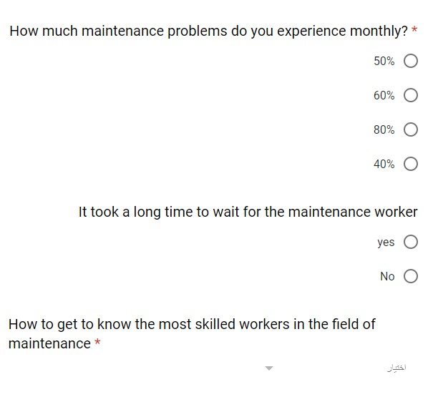

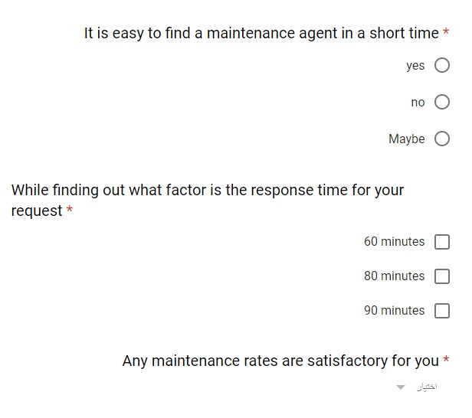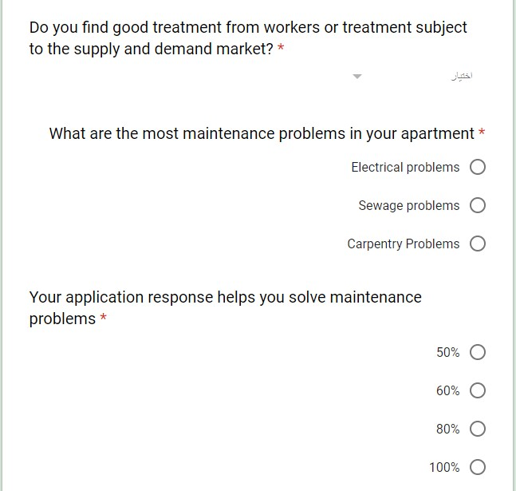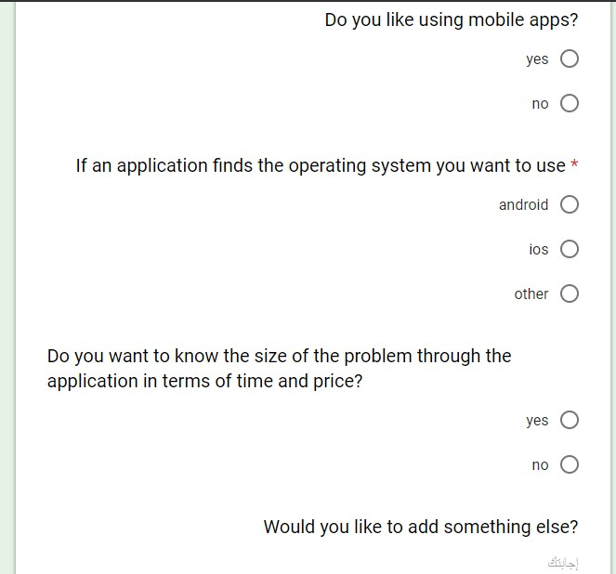

**Responses :**

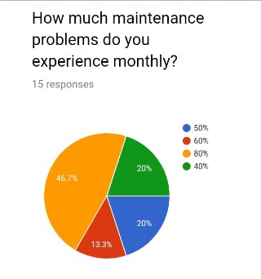

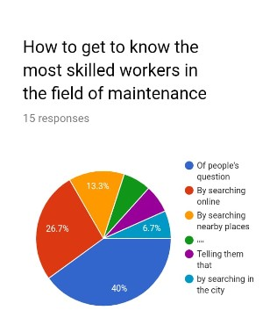

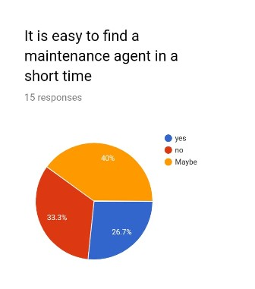

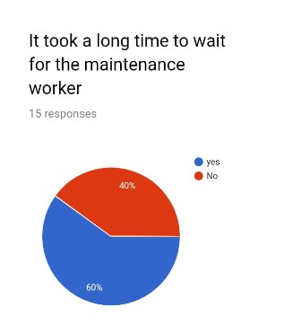

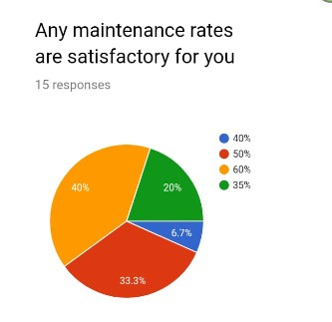

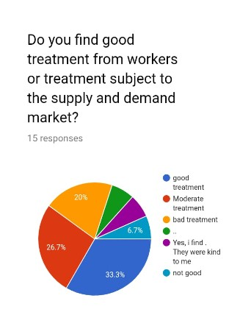

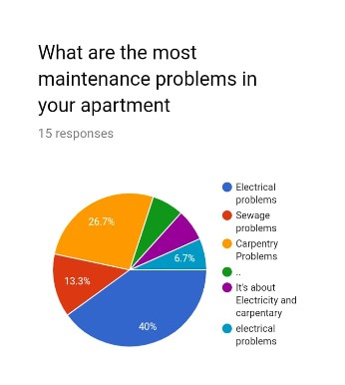

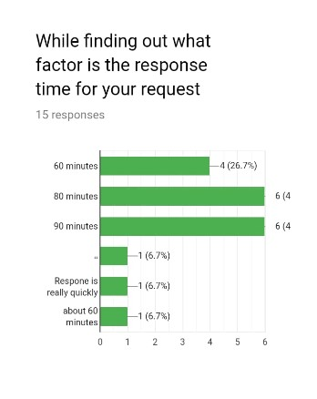

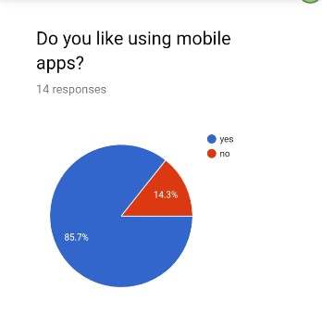

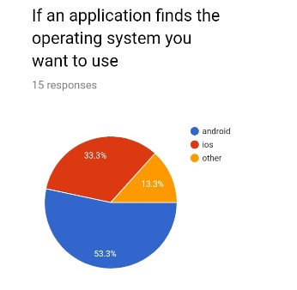

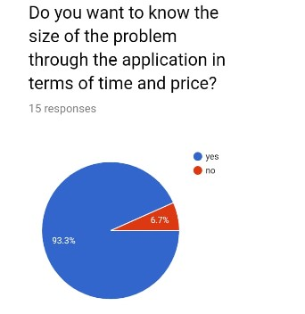

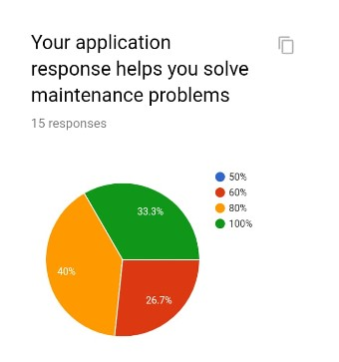

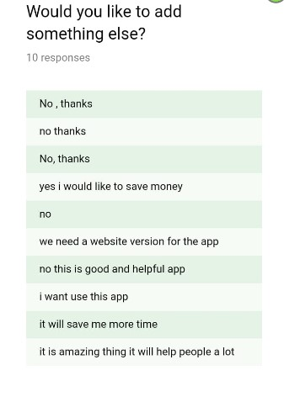

**Erd :**

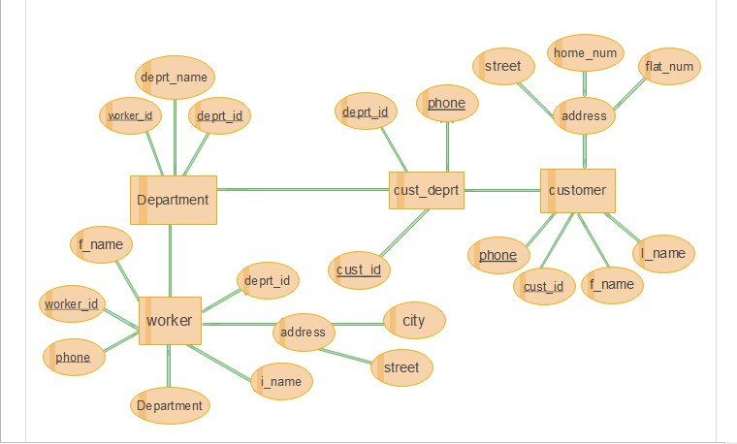

**Customer**

|  |  |  |  |  |
| --- | --- | --- | --- | --- |
| **Customae_ID** | F_Name | L_Name | **Phone** | Address |
| 1 | Ahmed | Ali | 023452 | (Cairo,Giza,Tanta) |
| 2 | Mohamed | Saeed | 023467 | Menoufya |
| 3 | Mostafa | Jabar | 023478 | Suze |
| 4 | Mahmoud | Yousef | 023489 | Tanta |

**1NF**

**Customer-2**

|  |  |  |  |  |
| --- | --- | --- | --- | --- |
| Customer_ID | F_Name | L_Name | Phone | Address |
| 1 | Ahmed | Ali | 023452 | Cairo |
| 1 | Ahmed | Ali | 023452 | Giza |
| 1 | Ahmed | Ali | 023452 | Tanta |
| 2 | Mahmoud | Saeed | 023467 | Menoufya |
| 3 | Mostafa | Jabar | 023478 | Suze |
| 4 | Mohamed | Yousef | 023489 | Tanta |

**Customer_3**

|  |  |  |  |
| --- | --- | --- | --- |
| Customer_ID | Phone | F_Name | L_Name |
| 1 | 023452 | Ahmed | Ali |
| 2 | 023467 | Mohamed | Saeed |
| 3 | 023478 | Mostafa | Jabar |
| 4 | 023489 | Mahmoud | Yousef |

**Customer_ 4**

|  |  |  |
| --- | --- | --- |
| Customer_ID | Phone | Address |
| 1 | 023452 | Cairo |
| 1 | 023452 | Giza |
| 1 | 023452 | Tanta |
| 2 | 023467 | Menoufya |
| 3 | 023478 | Suze |
| 4 | 023489 | Tanta |

**2NF**

**Customer_5**

|  |  |
| --- | --- |
| Customer_ID | Address |
| 1 | Cairo |
| 1 | Giza |
| 1 | Tanta |
| 2 | Menoufya |
| 3 | Suze |
| 4 | Tanta |

**3NF**

**Customer_6**

|  |  |
| --- | --- |
| Customer_ID | Phone |
| 1 | 023452 |
| 2 | 023467 |
| 3 | 023478 |
| 4 | 023489 |

**Customer_7**

|  |  |
| --- | --- |
| F_Name | L_Name |
| Ahmed | Ali |
| Mohamed | Saeed |
| Mostafa | Jabar |
| Mahmoud | Yousef |

**Worker**

|  |  |  |  |  |  |
| --- | --- | --- | --- | --- | --- |
| F_NAme | L_Name | Worker_ID | Phone | Address | Department |
| Ahmed | Mostafa | 1 | 012345 | Cairo,Banha | Electric |
| Mohamed | Jabar | 2 | 012346 | Tanta | Carpenter |
| Tamer | Lotfy | 3 | 012347 | Suze | Plumber |
| Emad | Ashraf | 4 | 012348 | Mehla | Black smitb |

**1NF**

**Work_1**

|  |  |  |  |  |  |
| --- | --- | --- | --- | --- | --- |
| F_NAme | L_Name | Worker_ID | Phone | Address | Department |
| Ahmed | Mostafa | 1 | 012345 | Cairo | Mehara |
| Ahmed | Mostafa | 1 | 012345 | Banha | Electric |
| Mohamed | Jabar | 2 | 012346 | Tanta | Carpenter |
| Tamer | Lotfy | 3 | 012347 | Suze | Plumber |
| Emad | Ashraf | 4 | 012348 | Mehla | Black smitb |

**Work_2**

|  |  |  |
| --- | --- | --- |
| Worker_ID | Phone | Address |
| 1 | 012345 | Cairo |
| 1 | 012345 | Banha |
| 2 | 012346 | Tanta |
| 3 | 012347 | Suze |
| 4 | 012348 | Mehla |

**Work_3**

|  |  |  |  |  |
| --- | --- | --- | --- | --- |
| F_NAme | L_Name | Worker_ID | Phone | Department |
| Ahmed | Mostafa | 1 | 012345 | Electric |
| Mohamed | Jabar | 2 | 012346 | Carpenter |
| Tamer | Lotfy | 3 | 012347 | Plumber |
| Emad | Ashraf | 4 | 012348 | Black smitb |

**2NF**

**Work_4**

|  |  |
| --- | --- |
| Worker_ID | Department |

**Work_5**

|  |  |  |  |
| --- | --- | --- | --- |
| F_NAme | L_Name | Worker_ID | Phone |

**3NF**

**Work_6**

|  |  |
| --- | --- |
| F_NAme | L_Name |

**Work_7**

|  |  |
| --- | --- |
| Worker_ID | Phone |

**Department_1**

|  |  |  |
| --- | --- | --- |
| **Work_ID** | **dep_ID** | **Deprt_name** |

**Department_2**

|  |  |
| --- | --- |
| **Work_ID** | **dep_ID** |

**Department_2**

|  |  |
| --- | --- |
| **dep_ID** | **Deprt_name** |